SpendWise: A Simple Backend Learning Project
Ideation Phase
Empathize & Discover

Date | 08 March 2026
Team ID | SWTID-2026-2148
Project Name | SpendWise
Maximum Marks | 4 Marks

Empathy Map Canvas:
An empathy map serves as an effective instrument for comprehending the thoughts, emotions, and actions of novices engaged in backend development. It aids in recognizing how learners engage with concepts like APIs, JWT authentication, and MongoDB, along with the difficulties they encounter when navigating intricate code. By developing an empathy map, the project can be evaluated from the viewpoint of the beginner, guaranteeing that the educational solution stays straightforward, pragmatic, and comprehensible.
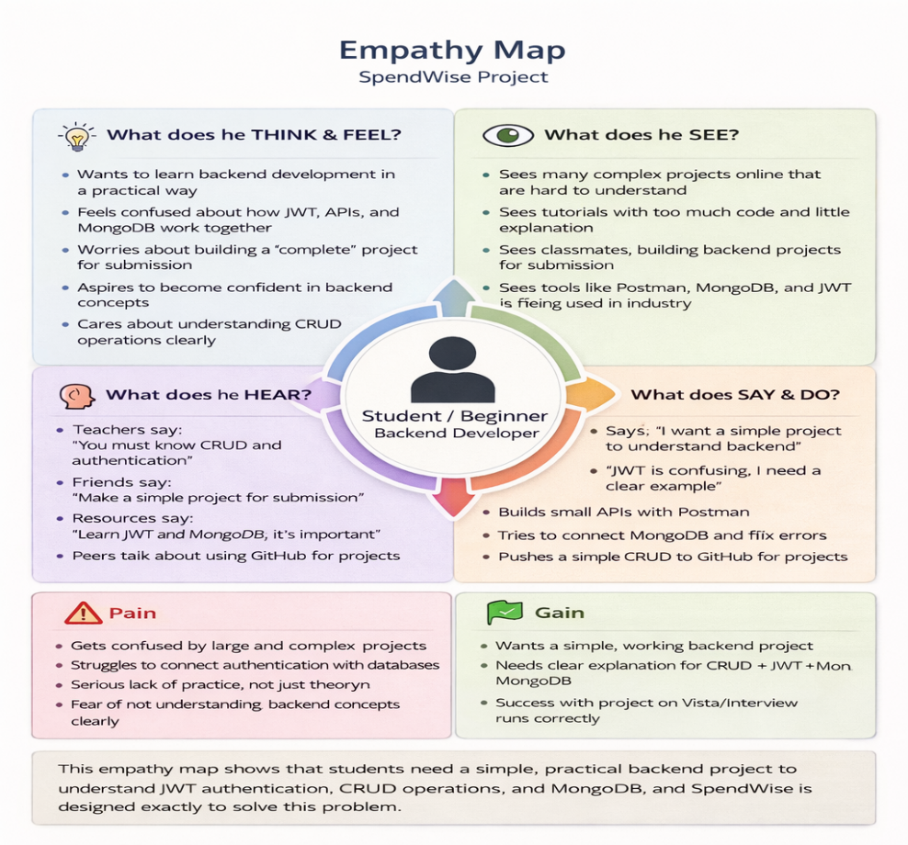
Example:

